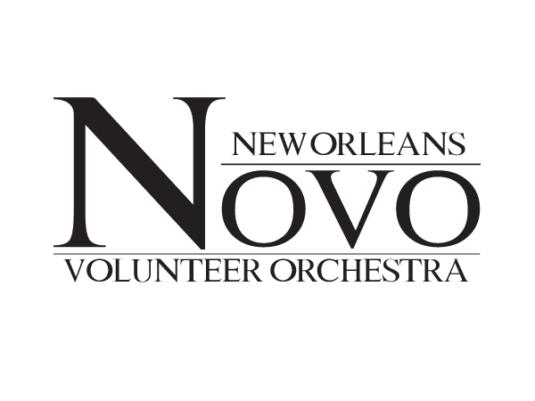
Corporate Sponsorship Form

Corporation Name:_______________________________ Address:_________________________________________
Phone Number:____________________________ Contact Person: _______________________________________

Please check that which apply:
Sponsor a Musician ($100 and above) [ ] Sponsor a Project ($500 and above) [ ]
Sponsor a Concert ($1,000 and above) [ ] Sponsor a Season ($4,000 and above) [ ]

Total Amount Donated: ___________________ Date: ______________________________________________
Please include donation in this letter by check or money order, made out to New Orleans Volunteer Orchestra.
Thank you for donating to the New Orleans Volunteer Orchestra, a 501(c)3 Non-Profit organization. Your donation is tax – deductible, and you will receive an official receipt in the mail at the above address.
Corporate Sponsorship, NOVO
7100 St Charles Ave
New Orleans LA 70118

